Integrate the Ingram Micro API solutions seamlessly into order, tracking, and fulfillment, to include real-time information and status updates.

Using Ingram Micro APIs
Follow this general process to begin using the Ingram Micro APIs:

https://developer.ingrammicro.com/reseller/register

- To register for Ingram Micro API Access, use the signup button at the top of the page to start this process. This process authorizes your existing Ingram Micro reseller account for API channel access.

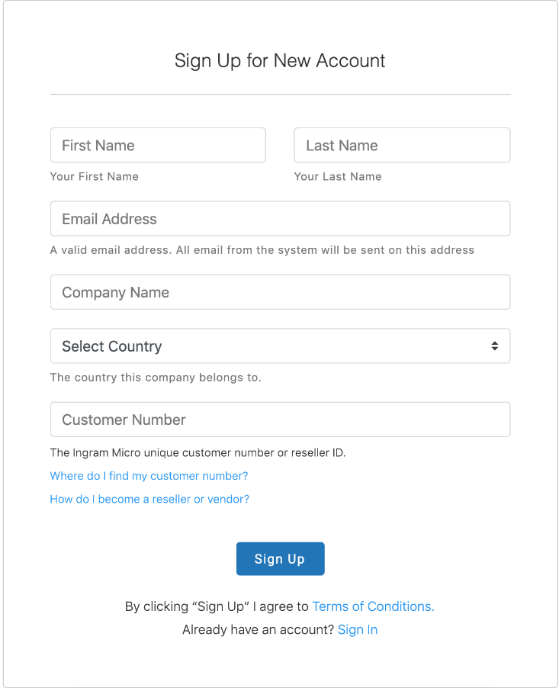
- Once the Signup has been approved by Ingram Micro’s Sales Team. Create a Production App by selecting +Add Production App.
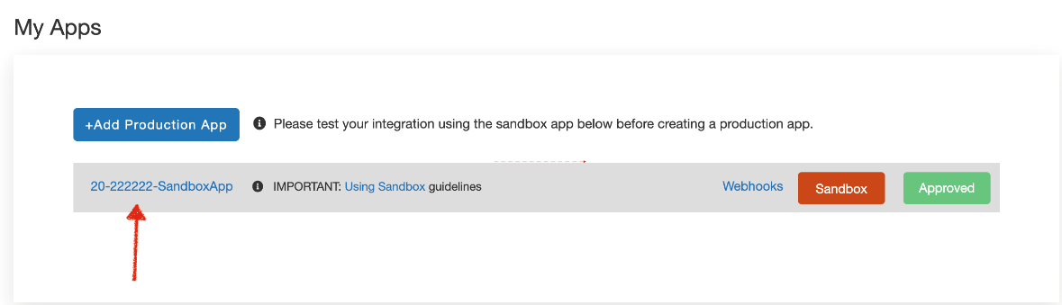

- Select the APIs you want to enable with your provider. Please Select all the API products you will be using with this App.
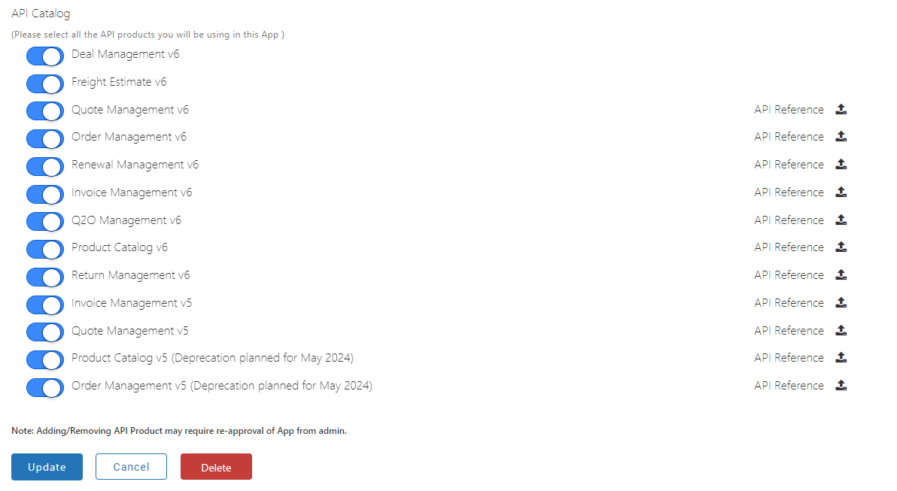

- Provide the Client ID and Client Secret IDs to your 3rd Party Provider
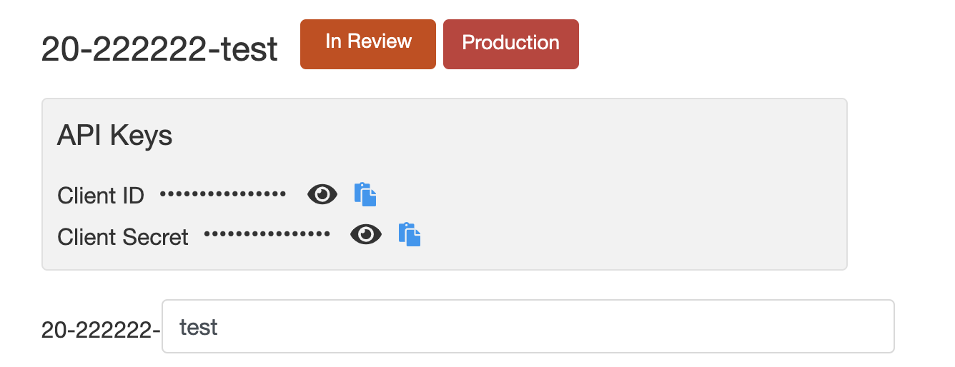
Contact electronic.services@ingrammicro.com for any questions

